Analyzing Smart Device Data for Enhanced Marketing Strategies at Bellabeat

**Objective**

We aim to understand user behavior patterns and provide data-driven recommendations for our marketing strategy.

**Context:**

Bellabeat, a high-tech manufacturer of health-focused products for women, aims to enhance its market presence and growth potential in the global smart device market. With a range of products designed to monitor various aspects of women's health, Bellabeat seeks to leverage data analytics to gain deeper insights into how customers use their products.

**DELIVERABLES:**

1. A clear statement of the business task.
2. A description of all data sources used.
3. Documentation of any cleaning or manipulation of data.
4. A summary of the analysis.
5. Supporting visualizations and key findings.
6. Top three recommendations based on the analysis.

**TIMELINE:**

The task will be completed within one week

**DATA USED:**

• **Source Name:** cyclistic

• **Description:** This source includes data collected directly from the bikes equipped with sensors and GPS devices.

• **Data Collected:** Trip start and end times, trip duration, distance traveled, routes taken, bike locations.

• **Collection Method:** Real-time data collection via integrated sensors and GPS trackers on each bike, transmitted to the central database.

• **Credibility:** High credibility as data is collected automatically and directly from the bikes, ensuring accuracy and minimizing human error.

**Data Insights**

**1. Steps Taken vs. Sedentary Minutes**

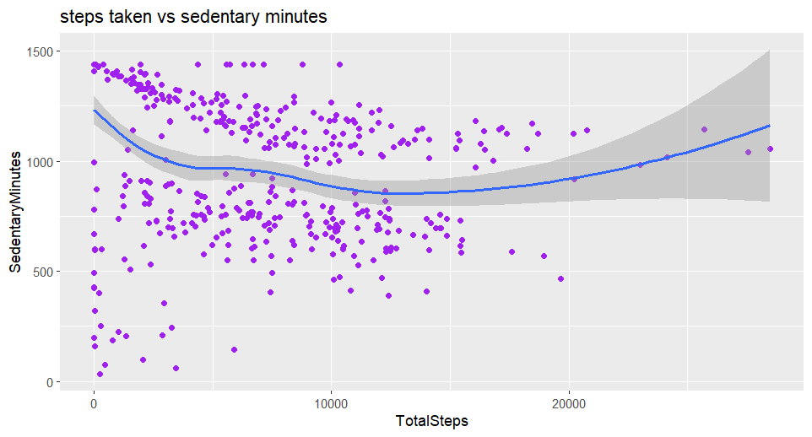

This scatter plot with a trend line illustrates the relationship between the number of steps taken and sedentary minutes. Key observations include:

* **Negative Correlation**: There is a general trend where an increase in the number of steps taken correlates with a decrease in sedentary minutes, up to a certain point.
* **Activity Levels**: Users with very high or very low step counts show varying sedentary times, suggesting diverse user profiles ranging from highly active to less active individuals.

**2. Minutes Asleep vs. Time in Bed**

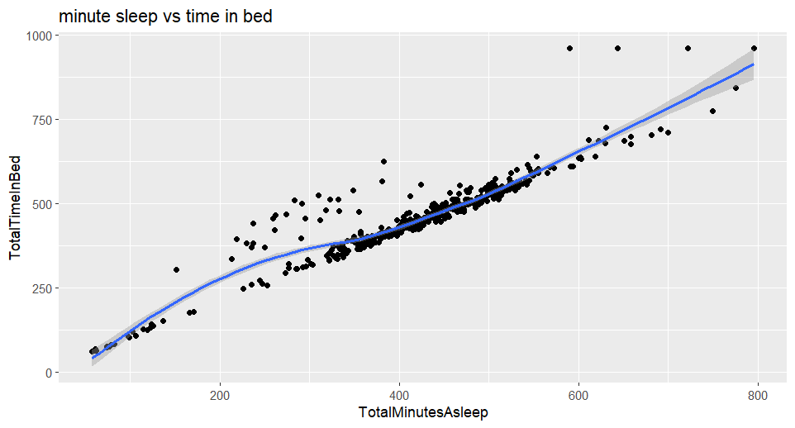

This scatter plot with a trend line shows the relationship between total minutes asleep and total time in bed. The insights are as follows:

* **Positive Correlation**: There is a strong positive correlation between total minutes asleep and time in bed, indicating that more time in bed generally leads to more sleep.
* **Sleep Efficiency**: The trend line suggests that while most users achieve an efficient sleep pattern, there are variations indicating potential areas for improving sleep quality.

**Recommendations for Marketing Strategy**

Based on our data analysis, we propose the following marketing strategies to enhance Bellabeat's market position:

1. **Targeted Health Campaigns**:
   * **Sedentary Users**: Develop campaigns that encourage sedentary users to increase their daily activity. Highlight the benefits of integrating more steps into their routine using Bellabeat devices.
   * **Active Users**: Promote advanced tracking features and health insights that cater to highly active users looking to optimize their performance.
2. **Sleep Improvement Programs**:
   * **Educational Content**: Create and distribute educational content about improving sleep quality, emphasizing how Bellabeat devices can help track and enhance sleep patterns.
   * **Personalized Insights**: Offer personalized sleep analysis and recommendations through the Bellabeat app to help users achieve better sleep efficiency.
3. **User Engagement Initiatives**:
   * **Community Building**: Foster a community of Bellabeat users where they can share their fitness journeys, challenges, and achievements. Use social media and in-app features to build this community.
   * **Gamification**: Introduce gamified challenges and rewards for meeting daily step goals or improving sleep metrics to increase user engagement and motivation.
4. **Product Positioning**:
   * **Holistic Health Focus**: Position Bellabeat devices not just as fitness trackers but as comprehensive health and wellness tools that support various aspects of women’s health, including activity, sleep, and mindfulness.
   * **Data-Driven Marketing**: Utilize insights from user data to tailor marketing messages and campaigns, ensuring they resonate with the diverse user base, from fitness enthusiasts to those seeking a healthier lifestyle.

**Conclusion**

Our analysis of smart device fitness data has provided valuable insights into user behavior, which will inform our marketing strategy. By targeting different user segments with tailored campaigns and emphasizing the holistic health benefits of Bellabeat products, we can drive growth and enhance our market position. We look forward to implementing these strategies and are excited about the potential for Bellabeat’s continued success.